Project: Visualizing Loan Data

Complete each section. When you are ready, save your file as a PDF document and submit it here: [https://classroom.udacity.com/nanodegrees/nd008/parts/c7cbb25d-deae-4be1-bc9c-71f465b849f8/project#](https://classroom.udacity.com/nanodegrees/nd008/parts/c7cbb25d-deae-4be1-bc9c-71f465b849f8/project)

# Step 1: Data Cleanup and Attribute Selection

*Clean up any missing information and choose the most important attributes you will explore further in your visualizations. List out the attributes (or variables) you plan to dive further with your visualizations. You should explore no more than 8 attributes. Please refer back to the* [*Data Cleanup course*](https://classroom.udacity.com/courses/ud977) *to help you clean up your data.*

Attributes that I would like to explore:

1. Loan Amount
2. Grade & Subgrade
3. Employment Length
4. Home Ownership
5. Issued Date
6. Loan Status
7. Purpose
8. Address State

# Step 2: Tableau Visualizations

Please make sure you follow the [rubric](https://review.udacity.com/#!/rubrics/329/view) and include Tableau Dashboards, Stories, and the appropriate visualizations (small multiples, scatter plot, bar chart, etc..) your reviewer expects your visualizations to contain.

Attach your visualizations as Tableau Workbooks in a zip file along with this report.

**IMPORTANT**: Please save the workbooks as **Tableau Public** workbooks to allow reviewers to access your workbooks.

# Step 3: Questions

*Answer the following questions. Refer to your online visualizations to back up your answers.*

1. How do the attributes differ between borrowers who pay back their loans versus those who don't?
   1. **Bonus Question**: If there are any differences between certain attributes, are the attributes statistically significant? A [t-test](https://en.wikipedia.org/wiki/Student%27s_t-test) or [mann-whitney-u](https://en.wikipedia.org/wiki/Mann%E2%80%93Whitney_U_test) test could help answer this question.

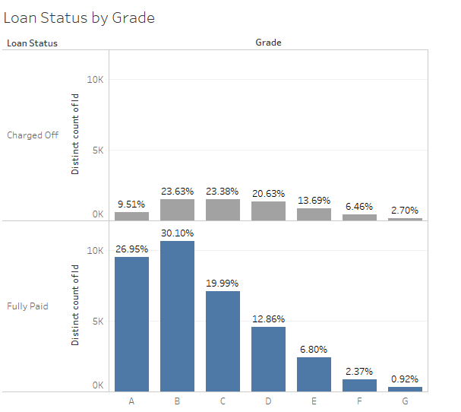

The attributes of lender who got charged off are unlikely to be in A grade loan, while it is spreading almost evenly across grade B,C,D. while lender who is fully paying has higher percentage in grade A&B, and trending lower in the other grades.

1. How do accepted and rejected loan data differ among different locations?

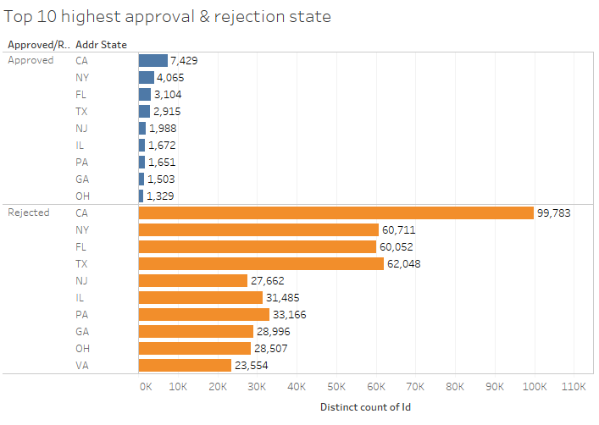

From the visualization the rejected and accepted loan does not differ so much in term of locations

The top 10 approved and top 10 rejected are similar, from CA,NY, FL, TX, NJ, IL , PA, GA & OH

1. How have issued loans changed over time?

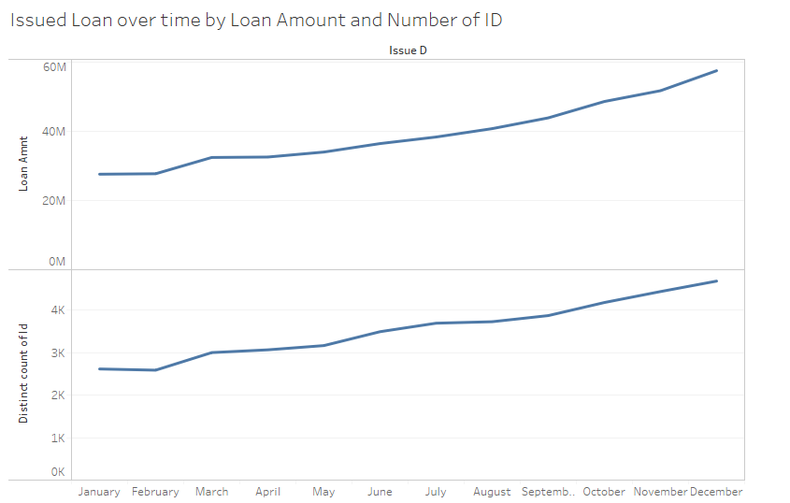

Issued loan is increasing over time in 2016

1. What is your additional question that you proposed? What is the answer? How did you come up with this question?
2. How is the spread of loan that meets the policy and does not met the policy across the grade? The highest loan which meets the policy is located in grade B, while the loan which does not meet the credit policy is in grade D

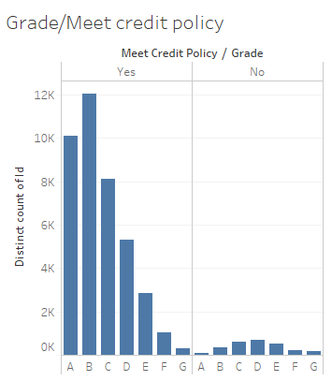

How is Customer profile of Lending Club?

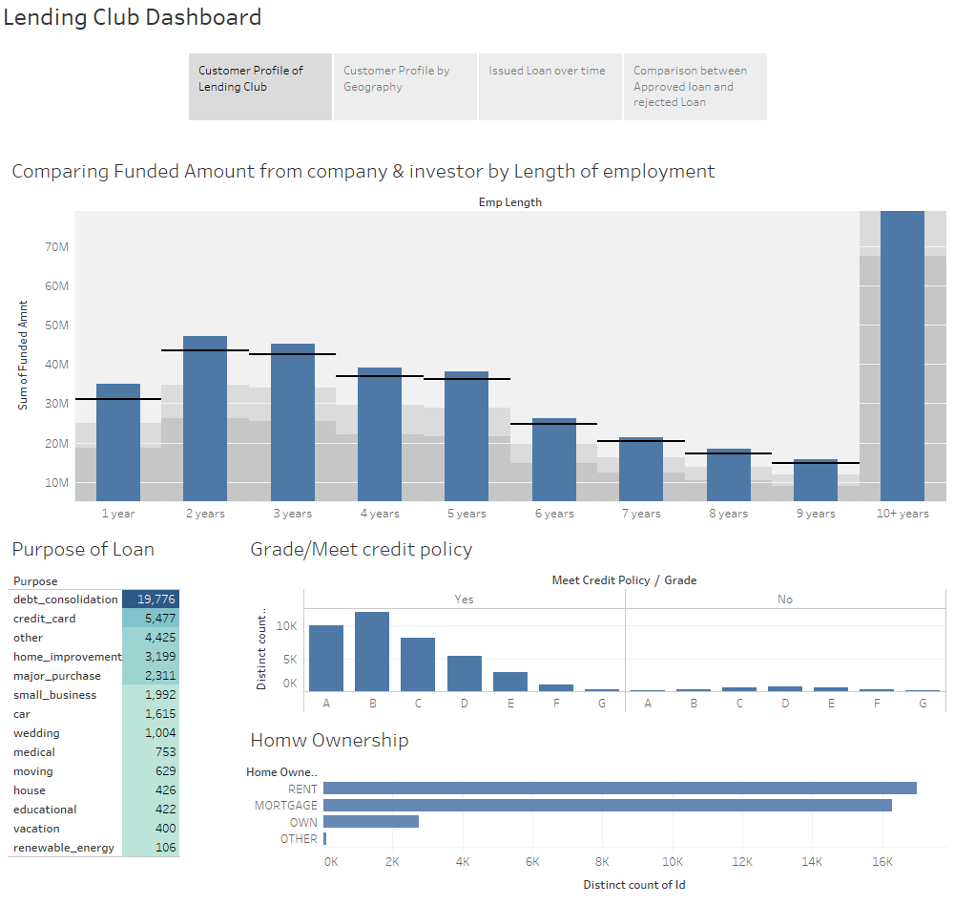

* Lending Club Approved clients are mostly applying for loan for Debt consolidation, followed by credit card purpose.
* Most of the clients are either renting place or currently on mortgage. It is very few loan applicants that own their own home.
* And the trend for the loan applicant employment work history increasing in trend from 1 to 5 years working experience, then the loan declining at 5-9, but there’s very high loan applicants who own working experience over 10 years+ .This may help segmenting the market whereas we can divide the market segment using age of 10+ working experience as primary target market and 2-5 years working experience as secondary target market